Survey Report

Topic:

**“Impact of Environmental Hazards on Women”**

**By**

Muhammad Ahsan Elahi

Muhammad Zain ul Abideen

**Supervisor:**

Zahid Zahoor (Director Roshni Organization)

**Roshni Organization Multan**

**Mamoona Development Foundation**

**Dedication**

We dedicate our project to our beloved parents. Without their support we could surely not be at this stage.

**Acknowledgement**

All praises are due to “Allah” Almighty Who is most merciful and beneficent. Who gives us courage to undertake uphill tasks and showers His blessings upon us. It is only with His blessings that we could complete this Survey Report. We would like to thank our worthy supervisor Sir Zahid Zahoor for his utmost help and guidance. We would also like to thank our honorable Chief Executive Madam Amna Hashmi and Project Manager Madam Farhana Burhan for her support, courage and guidance at every step. We would like to say thank to M. Asif, M. Qaswar, Mehmood ul Hassan, Amir Faheem and Abid Hussain for their support.

**Abstract**

Multan Environment Network has been established in Multan since 20th June 2013. This network consist of different NGO’s that are working in Multan such as Roshni Organization Multan, Mamoona Development Foundation, Aghaz Development Organization, Saiban Development, Rafa –e– Ama Society and Shirkat Ghah. In addition to these NGO’s Representative of Health Department, Representative of Bosan Town, Teachers and students of Environmental Sciences Bahauddin Zakariya University also in Multan Environment Network.

The major stimulants behind this project are the poor situation of environment, poor infrastructure and unavailability of pure drinking water for the inhabitants of Multan. Multan is one of populated city of province Punjab that produces huge amount of solid waste that is approximately 350 ton per week. Lack of sewerage system in many areas in the city as well as the unavailability of good water for crop fields.

This report provides latest condition of all the parameters that are essential for healthy life. Targeted areas were UC-53 & 59 we collected data by interviewing located community, secretary union councils, and representatives of all relevant departments.

We have tried to fulfill all the requirements necessary in meeting this challenge, which help us to create a sustainable environment in Multan.

|  |
| --- |
| **Contents** |
| 1. Introduction …………………………………………………… 7 |
| 1.1 Introduction of Roshni Organization Multan ……………... 8 |
| 1.2 Introduction of Mamoona Development Foundation …….... 9 |
| 1.3 Introduction of Multan Environment Network …………… 10 |
| 1.4 Brief introduction of report ……………………………….... 12 |
| 2 Preface ………………………………………………………….. 13 |
| 3 Questionnaire ………………………………………………….. 17 |
| 4 Survey Reports …………………………………………………. 22 |
| 4.1 Focus group Discussions ……………………………………. 23 |
| 4.1.1 Community women of Basti Gujjar Wali UC - 59………. 24 |
| 4.1.2 Community women of Basti Khoray Wali UC - 59……… 28 |
| 4.1.3 Community women of Basti Garry Wala UC - 59 ……… 33 |
| 4.1.4 Community women of Basti Jhaney Wala UC - 59 …….. 38 |
| 4.1.5 Community women of Basti Jhook Biloo UC - 59 ……….. 41 |
| 4.1.6 Community women of Mohallah Mahajreen UC - 53 …. 45 |
| 4.1.7 Community women of Cha kasli Wala UC - 53 ………... 49 |
| 4.1.8 Community women of Mohallah Raj Ghat UC - 53 ……. 53 |
| 4.2 Door to door survey ……………………………………….... 56 |
| 4.2.1 Door to door survey at UC - 53 ……………………….. 57 |
| 4.2.2 Door to door survey at UC - 59 ……………………….. 59 |
| 5 Situation Analysis ……………………………………………… 64 |
| 5.1 Graphical Explanation ……………………………………… 65 |
| 6 In-depth Interviews …………………………………………… 73 |
| 6.1 Pakistan Girls Guide Association …………………………... 74 |
| 6.2 Dr. Zahid …………………………………………………… 78 |
| 6.3 Dr. Sibtain …………………………………………………. 80 |
| 6.4 Assistant Director Local Government ……………………. 83 |
| 6.5 Secretary Union Council ………………………………….. 86 |
| 6.6 District Officer Social Welfare ……………………………. 89 |
| 6.7 District Officer Solid Waste ………………………………. 91 |
| 6.8 District Officer Forest Department ……………………….. 94 |
| 6.9 Inspector of Environment Protection Department ……….. 98 |
| 6.10 Express News Reporter ………………………………… 101 |
| 7 Discussion & conclusion ……………………………………. 102 |

**Chapter # 1**

**Introduction**

**1.1 Introduction of Roshni Organization**



Roshni Organization was found in 1992 with a clear focus in serving the deprived people of southern and central Punjab. It started work with the philosophy of community development through community participation. The mission of the organization is “Bringing changes in the lives of the disadvantaged groups providing them access to quality education and enabling them to explore their potentials especially women.” A Group of activist took initiative, started work on education initially aware people about the importance of education. Roshni Organization got registered from Social Welfare Department under voluntarily social welfare act 1961. Major focus of Roshni Organization is Education, Environment and Capacity building. A pool of experts is its board member. Now Roshni Organization is working at National level. It has experience to work with different National and International Organizations.

**1.2 Introduction of Mamoona Development Foundation**

****

Mamoona Development Foundation was established in 1995 with a clear focus in serving the deprived people of southern and central Punjab. MDF located areas where education and health facilities were inexistent. MDF took the initiative with the non-formal school to provide quality education in the remotest areas. Later lady health workers were also spread in areas where women had no access to the health centers. MDF has also the privilege of running successful awareness campaigns and also, steps were taken for poverty alleviation.

**1.3 Introduction of Multan Environment Network**

Multan Environment Network has been established in Multan since 20th June 2013 as a result of utmost working of Roshni Organization and Mamoona Development Foundation. It’s a basic need of Multan to make a network related to Environment as the environment of Multan degraded fast.

Formation of network needs basic criteria on which all the NGO’s in Multan work for the betterment of environment at the same platform. So an invitation regarded member of “Multan Environment Network” was sent to all other NGO’s.

Network established and it consists different NGO’s that are working in Multan with different aims named as; Roshni Organization Multan, Mamoona Development Foundation, Saiban Development, Rafa -e- Ama Society, Aghaz Development Organization, Representatives of Health Department, Representatives of Bosan Town and Students of Department of Environmental Sciences Bahauddin Zakariya University.

In the meeting of MEN it was decided to conduct a research on different areas of Multan to collect the latest situation of environment because it provides a base line to work for the betterment of environment and to provide sustainable environment for inhabitants of Multan.

With the help of Almighty Allah and guideness of our worthy supervisor Sir Zahid Zahoor we conducted research on situation of Environment on targeted areas UC 53 & 59, created a base line which helps us to work and make environment safe.

**1.4 Brief Introduction of Report**

Aim and Objectives:

We work with aim “To improve the environmental situation in Multan.” To conduct base line from targeted area within two months.

**Introduction**

We undertook research in two Union Councils; 53 & 59 (suraj miani). In that survey we had discussions with the community people, collected information by arranging Door to Door survey (DTD), conducting Focus Group Discussions (FGD), arranging awareness seminar with community people, observing case studied and by doing in-depth interviews.

In-depth interviews were taken with Lady Health Workers, Chair person of Pakistan Girls Guide Association, Dr. Sibtain, Assistant Director Local Government, Secretary Union Council, District Officer Social Welfare, District Officer Solid Waste, District Officer Parks and Horticulture, District Officer Forest Department, Executive Engineering of Irrigation Department, Inspector of Environment Protection Agency, District Coordinator Officer and Chief Reporter Express News.

**Chapter # 2**

**Preface**

**Preface:**

In this report we are trying to explain the linkages of environment and women in terms of being victims of the degradation and their particular gender roles in the society. In this report a modest attempt has been made to theoretically discuss environmental degradation and to identify the major environmental hazards, concerns and critically analyze the effects of such degradation on women’s health.

In Multan, environment is in its critical situation due to poor planning, poor infrastructure, and unavailability of pure drinking water in most of the areas, insufficient supply of pure vegetables, fruits etc, and poor system of managing solid waste as well as Sewerage water.

In rural areas all the crop fields have to use sewerage water for irrigation purposes due to unavailability of pure and clean water. “Although women and men concern with the environment the same way, in many ways they also use plant and animals, land and water in different ways. Whether the air, water or land is clean or polluted may not have the same affect on men and women because of their different activities and socio economic role.

In Multan, mostly areas adversely affected because of the vicious circle of poverty. In the poor areas women constitute half of the entire population and they are the poorest of the poor——not merely in wealth but in every other index of development. So naturally women are the worst victims of environmental degradation as they depend upon the renewability of natural systems to provide them food, fuel, water and shelter for existence.

In Rural Areas women collect food, fodder and fuel for family consumption from trees and forests. Deforestation results in the reduction in the variety of forest products which is of particular relevance for women. If the supply shrinks then the women are affected disproportionally by less food, less fuel, harder work.

Industrialization with in populated areas causes massive pollution of land, air and water that destroys the nature and degrades the environment. Smoke from the industry, use of chemical and toxic components, and use of automobiles, hazardous industrial wastes have led to the extreme deterioration of environment. Both ground water and surface water are vulnerable to pollution from industrial effluent and municipal waste. Due to all above reasons pollution is major problem which is increasingly getting high in Multan.

“For women, disasters (flood) cause unbearable social crises and sufferings. In fact, women are the worst victims of natural and manmade disasters when compared to men. Disasters devastate the environment, but the women have to still perform their regular duties like preparation of food, collection of water and fuel, often under impossible circumstances. The physical burden of coping falls heavily on women.”

“In Rural as well as Urban Areas exposure of some toxic substances including lead, mercury, arsenic, cadmium, pesticides, solvents, and household chemicals can increase the risk of miscarriage, preterm birth, and other pregnancy complications in women. These and other environmental toxins or contaminants can also harm the developing bodies of fetuses and infants. This is due to low level of literacy in women.”

“Large numbers of women are affected health wise, by either of the environmental contaminants in one way or the other. This is because, broader range of chemicals including many that are associated with everyday products such as household cleansers, personal beauty care products have much impact on women’s reproductive health.

Women and children are 14 times more likely to die than men during natural disaster. Women should have better access to climate change information and related knowledge and skills, services, such as doctors and veterinaries.”

**Chapter # 3**

**Questionnaire**

1. Are you satisfied the cleanliness of your area?
2. Yes b) No c) Sometime d) Non
3. Is there any proper management of solid management in your area?
4. Yes b) No c) partially d) Not known
5. What are the reasons of Environmental pollution in your area?

a) Poor sewerage system b) Accumulation of garbage

c) Smoke d) All

4) Do you think women effect more due to Environmental pollution?

a) Yes b) No c) Partially d) Maximum

5) Is the water of your area is dangerous for health?

a) Yes b) No c) partially d) Maximum

6) Is there any water filtration plant in your area?

a) Yes b) No c) exist, not in work d) Not working

7) Is there any pollution causing factory in your area?

a) Yes b) No c) Not known d) other

8) At which extant pollution damaging factory damage your health?

a) Asthma b) Cancer c) Not known d) other

9) Is garbage burn in your area?

a) Yes b) No c) Not known d) Partially

10) Did you think pollution is increasing in your area?

a) Yes b) No c) Partially d) Maximum

11) Is there any environmental department visit your area?

a) Yes b) No c) Not known d) Name

12) How many trees present in your area?

a) More b) Maximum c) Enough d) Minimum

13) Did you think the major cause of cancer in women is Environmental pollution?

a) Yes b) No c) Partially d) Not known

14) Did you think pollution causing bad impact on Environment?

a) Yes b) No c) Partially d) Not known

15) What is the main reason of Environmental pollution in your area?

a) Air pollution b) Water pollution

c) Land pollution d) All

16) Did you think the relevant department should work for the betterment of environment in your area?

a) Yes b) No c) Partially d) Maximum

17) If any department is in working, are you satisfied?

a) Yes b) No c) Partially d) Maximum

18) Did you think it is your responsibility to clean environment?

a) Yes b) No c) Partially d) Maximum

19) Who throw out household garbage?

a) Children b) Women c) Men d) Swapper

20) Is pesticide present in your home?

a) Yes b) No c) Partially d) Not known

21) Who washes vegetables, fruits in your home?

a) Children b) Women c) Men d) Mad

22) Did you work in crop field?

a) Yes b) No c) Sometime

23) Is there any skin infection on your body?

a) Yes b) Not know c) Early stages d) No

24) Do you consult a doctor for Regularly Checkup?

a) Yes b) No c) Sometime

**Chapter # 4**

**Survey Reports**

**Chapter # 4.1**

**Focus Group Discussion**

**4.1.1 Community women of Basti Gujjar Wali UC - 59**

At 9:30 A.M team went to targeted area for survey. During survey of the area it was being noted that the environment of the area too much affected by the pollution. During survey we observed the open holes in the center of the street which was very dangerous for children. Sewerage system was too badly administrated. Many streets were full of sewerage water which is most dangerous for health of the inhabitants.

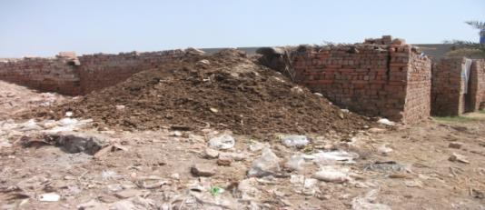

Solid waste in basti Gujjar wala accumulated near the house, dated 2/7/13

In this area many brick - Kilns worked and contaminated the environment. Dark blackish smoke emitted from the chimneys which was full of dangerous gases such as CO2, methane, CO and HF without any purification. These brick - kilns were in those areas which were very congested and populated.

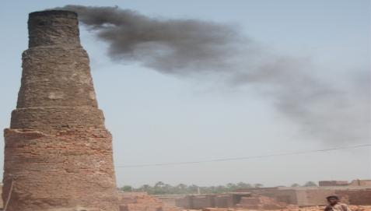

Brick – kiln emitted hazardous smoke in populated area of basti Gujjar wala, dated 2/7/13

The smoke exhausted from the chimneys in the atmosphere is responsible for the diseases such as Asthma, Skin infections, Lung diseases, as well as the respiratory diseases in the inhabitants, mostly in female and children. The length of chimneys of brick - kilns are not enough high to control the pollution. The people that live in this area are in very critical situation due to the smoke.

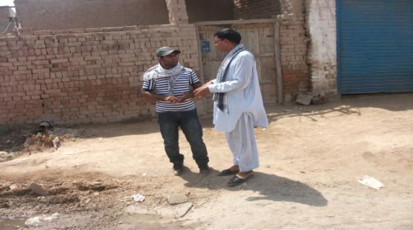

Discussion with Mr. Amin at environmental pollution in his area, dated 2/7/13

We met Mr. Amin during the survey and he told us that the smoke from the factories have prolonged effects on the health of the people. They all were very upset due to these factories. He also told that a survey is conducted from an organization and the team issued notes from the environmental department to stop the brick lings. The factories owners had a stay from the department now the date is delayed but they did not stop their work. Mr. Amin also discussed the different environmental issues they faced.

He told that there is no proper sewerage system, solid waste management. There are many places where sewerage water stayed for long. The people of the area are very much disappointed from the relevant departments such as WASA, Solid Waste Management. Team also observed this problem and visited the places where garbage and house hold waste gathered and get burned.

Team visited Roshni School and met with Miss Robina Rasool and discussed environmental issues that are subjected in this area. She told the negligence of WASA and Solid Waste Management.

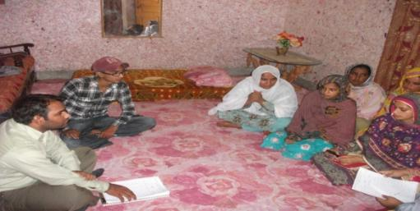

Discussion with community females of Basti Gujjar wala, dated 3/7/13

She further discussed an important issue that the female faced severely; she told that excessive spray of different pesticides etc. is a major cause of many diseases in female such as skin cancer, allergic diseases

**4.1.2 Community women of Basti Khoray Wali**

**UC – 59**

Today we visit Basti Khoray Wali for survey. At 9:30 A.M team went to targeted area for survey. During survey of the area it is being noted that the environment of the area very poor and affected by the pollution.

During survey we observed there is no sewerage system in whole Basti. All the municipal wastes are thrown in crop fields. Many streets were full of sewerage water which is most dangerous for health of the inhabitants.

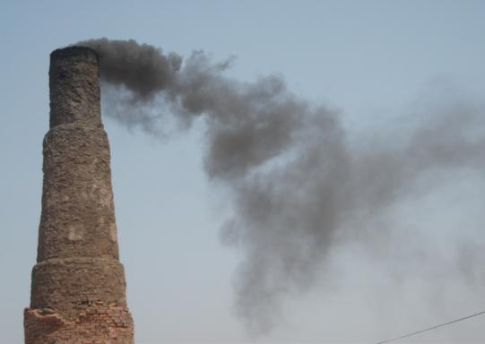

Brick – kiln emitted dangerous smoke including CO2, CO and HF in the atmosphere at basti Khoray wala, dated 4/7/13

In this area many brick - kilns work and contaminated the environment. Dark blackish smoke emitted from the chimneys which was full of dangerous gases such as CO2, methane, CO and HF without any purification. These brick - kilns are in that area which is very congested and populated. The smoke exhausted from the chimneys in the atmosphere is responsible for the diseases such as Asthma, Skin infections, Lung diseases, as well as the Respiratory diseases in the inhabitants, mostly in female and children. The length of chimneys of brick - kilns are not enough high to control the pollution. The people that live in this area are in very critical situation due to the smoke.

Team observed that the smoke from the factories has prolonged effects on the health of the people. The people of the area were all very upset due to these factories. They told us there was a survey conducted from an organization and they issued note from the environmental department to stop the brick - kilns. The factories owner had a stay from the department now the date is delayed but they did not stop their work. The people of the area also discussed the different environmental issues they faced. They said that there is no proper sewerage system, solid waste management. There are many places where sewerage water stayed for long. The people of the area are very much disappointed from the relevant departments such as WASA, Solid Waste Management.

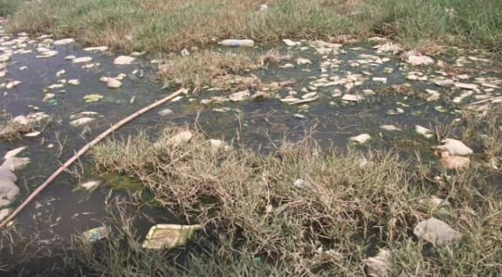

Sewerage water in street of Khoray wala, dated 4/7/13

Team also observed this problem and visited the places where garbage and house hold waste gathered and get burned.

Team visited Roshni School and met with Miss Balqees and discussed environmental issues that are subjected in this area. She told the negligence of WASA and Solid Waste Management. She further discussed an important issue that the female faced severely; she told that excessive spray of different pesticides etc. is a major cause of many diseases in female such as skin cancer, allergic diseases.

|  |  |
| --- | --- |
| G:\Work\New folder\LostFile_JPG_50978800.jpg | G:\Work\New folder\LostFile_JPG_50973776.jpg |

Discussion with community females of basti Khoray wala, dated 4/7/13

In the Basti Khoray Wali different diseases are very common in females such as Allergic diseases, skin infections, asthma. In every home two or three members are affected by the air pollution severely and fetch to poor health.

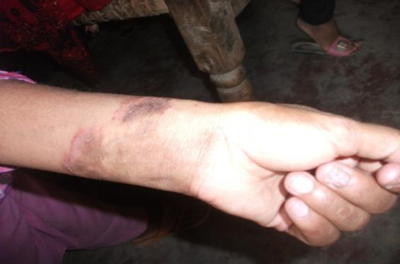Skin of woman affected by pollution in basti Khoray wala, dated 4/7/13

Team surveyed door to door of the area and discussed environmental issues from the inhabitants. Fardoos mustaqeem, Faizan Ghulam Fareed, Hanifan Allah Bakhsh, Zulaikha Yaseen, Ammara, Qulsoom, Razia, Madiha, Mugheerah Malik, and Amna are very upset due to Air pollution in their area. They requested the government, M N A, M P A, Environment Protection Department, Solid Waste Management, W A S A, for their rehabilitation and do work for managing the problems they faced.

**4.1.3 Community women of Basti Garry Wala UC - 59**

Today we visit Basti Garry Wala for survey. At 10:00 A.M team went to targeted area for survey. During survey of the area it is being noted that the environment of the area is poor and affected by the pollution.

During survey we observed there is no sewerage system in whole Basti. All the municipal wastes are thrown in crop fields. Many streets were full of sewerage water which is most dangerous for health of the inhabitants.

The people of the area also discussed the different environmental issues they faced. They said that there is no proper sewerage system, solid waste management. There are many places where sewerage water stayed for long. The people of the area are very much disappointed from the relevant departments such as WASA, Solid Waste Management.

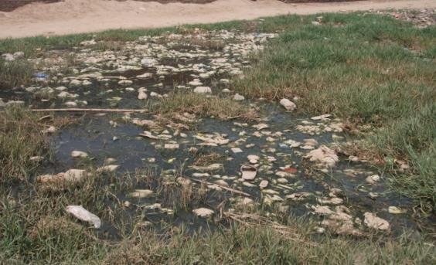

Lack of sewerage system at basti Garry wala, domestic effluents stayed near the street, dated 4/7/13

The drinking water of the area is not good. It harms the health and people forced to drink that polluted water because there is no water filtration plant. A water filtration plant was launched in the days of elections but the project didn’t complete yet.

Due to the irrigation from sanitation a lot of diseases spread throughout the area. Plants as well as people affected from this practice mostly female and children. People of Basti Garry Wala requested to relevant department to control the use of sewerage water as irrigation. Solid waste is also burnt in this area. Team also observed this problem and visited the places where garbage and house hold waste gathered and get burned.

Team visited Roshni School and met with Miss Aasia Bano and discussed environmental issues that are subjected in this area. She told the negligence of WASA and Solid Waste Management. She further discussed an important issue that the female faced severely; she told that excessive spray of different pesticides etc. is a major cause of many diseases in female such as skin cancer, allergic diseases.

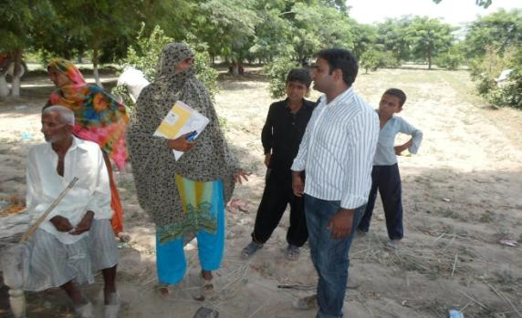

Discussion on environmental effects on women with Miss Shamim, dated 4/7/13

In the Basti Garry Wala different diseases are very common in females such as Allergic diseases, skin infections, asthma. In every home two or three member is affected by the air pollution severely and fetch to poor health.

Team surveyed door to door of the area and discussed environmental issues from the inhabitants. Ammara, Rehmat Elahi, Hamedan Mai, Saeedan Bibi, Tehrem Fatima, Irshad Bibi, Qulsoom, Razia, Madiha, Amber Malik, Amna are very upset due to Air pollution in their area. They requested the government, M N A, M P A, Environment Protection Department, Solid Waste Management, W A S A, for their rehabilitation and do work for managing the problems they faced.

After door to door survey a meeting with community women was held at Roshni School under the kindness of Miss Sumaira Nousheen. The purpose of meeting with community women was too aware them from hazards of environmental pollutions and discussed the major environmental issues that they faced.

Women attended meeting with their interest and discussed freely about environment. They said that there is no facility of Gas, due to this they forced to burn wood for cooking purposes. So they affected allergic and skin diseases.

They also told that the drinking water of the area is also poor. Due to the poor quality of drinking water there are so many diseases. In whole area there is only one water filtration plant but the plant didn’t work. They further told that the area was surveyed by Shirkat Ghah, Aghaz Foundation and F D O. These organizations launched different activities but no one was about environment.

The female said that there is need of dispensary or small hospital because in their area no any dispensary is working.

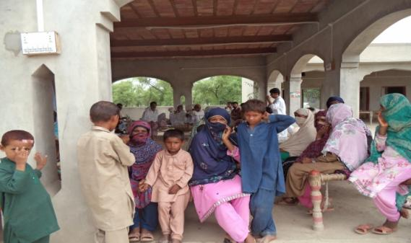

Community people attending Environment awareness seminar at basti Garry wala, dated 4/7/13

Female who attended the meeting were Pathano Mai, Bakho Mai, Nasreen, Saeeda, Sakeena, Gurya Mano, Faizaan Mai, Iffat, Shehnaz, Mumtaz, Aqsa and Iqra.

**4.1.4 Community women of Basti Jhany Wala UC - 59**

Today we visit Basti Jhany Wala for survey. At 01:00 P.M team went to targeted area for survey. During survey of the area it is being noted that the environment of the area very poor and affected by the pollution.

During survey we observed there is no sewerage system in whole Basti. All the municipal wastes are thrown in crop fields. Many streets were full of sewerage water which is most dangerous for health of the inhabitants. The people of the area also discussed the different environmental issues they faced. They said that there is no proper sewerage system, solid waste management. There are many places where sewerage water stayed for long.

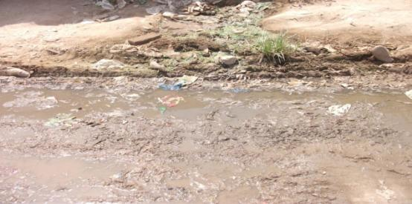

Waste water along the street at basti Jhany wala, dated 6/7/13

The people of the area are very much disappointed from the relevant departments such as WASA, Solid Waste Management. The drinking water of the area is not good. It harms the health and people forced to drink that polluted water because there is no water filtration plant. A water filtration plant was launched in the days of elections but the project didn’t complete yet.

Due to the irrigation from sanitation a lot of diseases spread throughout the area. Plants as well as people affected from this practice mostly female and children.

People of Basti Jhany Wala requested to relevant department to control the use of sewerage water as irrigation. Solid waste is also burnt in this area. Team also observed this problem and visited the places where garbage and house hold waste gathered and get burned.

Team visited Roshni School and met with Miss Shehnila and discussed environmental issues that are subjected in this area. She told the negligence of WASA and Solid Waste Management. She further discussed an important issue that the female faced severely; she told that excessive spray of different pesticides etc. is a major cause of many diseases in female such as skin cancer, allergic diseases.

In the Basti Jhany Wala different diseases are very common in females such as Allergic diseases, skin infections, asthma. In every home two or three member is affected by the air pollution severely and fetch to poor health. Team surveyed door to door of the area and discussed environmental issues from the inhabitants.

Kaneeza, Aqsa, Farzana, Najma, Maryam, Sadia and Samreena are very upset due to Air pollution in their area. They requested the government,

M N A, M P A, Environment Protection Department, Solid Waste Management, W A S A, for their rehabilitation and do work for managing the problems they

**4.1.5 Community women of Basti Jhook Biloo UC - 59**

Today we visit Basti Jhook Biloo for survey. At 10:00 A.M team went to targeted area for survey. During survey of the area it is being noted that the environment of the area very poor and affected by the pollution.

During survey we observed there is no sewerage system in whole Basti. All the municipal wastes are thrown in crop fields. Many streets were full of sewerage water which is most dangerous for health of the inhabitants. The people of the area also discussed the different environmental issues they faced. They said that there is no proper sewerage system, solid waste management. There were many places where sewerage water stayed for long. The people of the area were very much disappointed from the relevant departments such as WASA, Solid Waste Management. The drinking water of the area is not good. It harms the health and people forced to drink that polluted water because there is no water filtration plant.

A water filtration plant was launched in the days of elections but the project didn’t complete yet. Due to the irrigation from sanitation a lot of diseases spread throughout the area. Plants as well as people affected from this practice mostly female and children. People of Basti Jhook Biloo requested to relevant department to control the use of sewerage water as irrigation. Solid waste is also burnt in this area. Team also observed this problem and visited the places where garbage and house hold waste gathered and get burned.

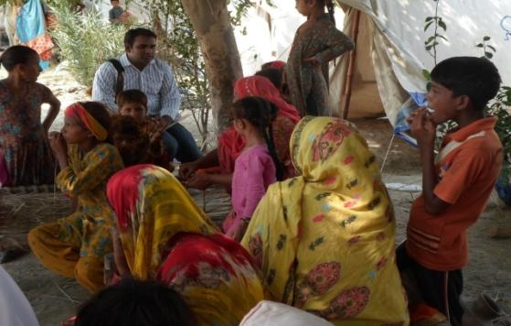

Discussion with community women at basti Jhook Biloo, dated 8/7/13

Team visited Roshni School and met with Miss Kashifa and discussed environmental issues that are subjected in this area. She told the negligence of WASA and Solid Waste Management. She further discussed an important issue that the female faced severely; she told that excessive spray of different pesticides etc. is a major cause of many diseases in female such as skin cancer, allergic diseases. In the Basti Jhook Biloo different diseases are very common in females such as Allergic diseases, skin infections, asthma. In every home two or three member is affected by the air pollution severely and fetch to poor health.

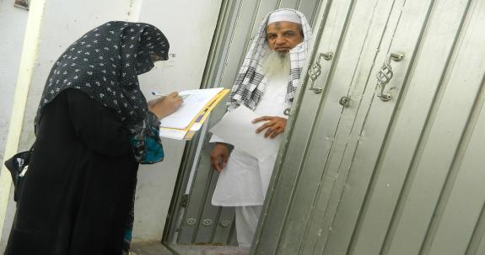

Door to door survey for collecting recent information of inhabitants at environmental issues, dated 8/7/13

Team surveyed door to door of the area and discussed environmental issues from the inhabitants. Muhammad Javed, Manzooran Mai, Naseema, Shamim Bibi, Naheed, and Pathana Mai are very upset due to Air pollution in their area. They requested the government, M N A, M P A, Environment Protection Department, Solid Waste Management, W A S A, for their rehabilitation and do work for managing the problems they faced.

**4.1.6 Community women of Mohallah Mahajreen UC-53**

Today we visit for survey. At 09:00 A.M team went to targeted area for survey. During survey of the area it is being noted that the environment of the area very poor and affected by the pollution.

During survey we observed there is no sewerage system in whole Basti. All the municipal wastes are thrown in crop fields. Many streets were full of sewerage water which is most dangerous for health of the inhabitants. The people of the area also discussed the different environmental issues they faced. They said that there is no proper sewerage system, solid waste management. There were many places where sewerage water stayed for long. The people of the area were very much disappointed from the relevant departments such as WASA, Solid Waste Management.

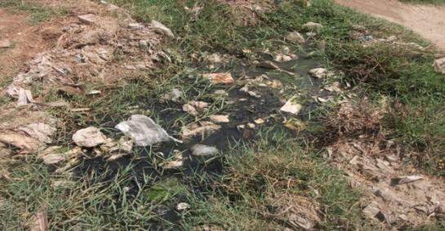

Poor situation of management of waste water at Mohallah Mohajreen, dated 10/7/13

The drinking water of the area is not good. It harms the health and people forced to drink that polluted water because there is no water filtration plant. A water filtration plant was launched in the days of elections but the project didn’t complete yet. People of Basti requested to relevant department to control the use of sewerage water as irrigation. Solid waste is also burnt in this area. Team also observed this problem and visited the places where garbage and house hold waste gathered and get burned.

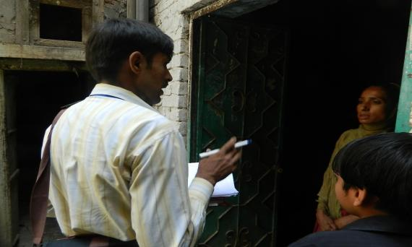

Door to door survey at Mohallah Mohajreen, dated 10/7/13

Team visited Roshni School and met with Miss Shahida and Miss Naseem and discussed environmental issues that are subjected in this area. She told the negligence of WASA and Solid Waste Management. In the Basti different diseases are very common in females such as Allergic diseases, skin infections, asthma. Team arranged a meeting with community females and did awareness about hazardous effects of environmental pollution and discussed them on their environmentally related problems.

Many women attended the meeting; their names are Tayabba Fatima, Laraib, Qurtulain, Shumaila, Chanda, Shaishta, Pakeeza, Irum, Neelam, Misha, Rimsha, Aimen, Bushra, Zaitoona, Sana, Kanwal and Humaira.

Community females said that the major problem in their area is management of sewerage water. They said that the WASA department did not work in their whole Union Council. They requested the government, M N A, M P A, Environment Protection Department, Solid Waste Management, W A S A, for their rehabilitation and do work for managing the problems they faced.

**4.1.7 Community women of Cha kasli Wala UC - 53**

Today we visit Cha kasli Wala for survey. At 11:30 A.M team went to targeted area for survey. During survey of the area it is being noted that the environment of the area very poor and affected by the pollution.

During survey we observed there is no sewerage system in whole Basti. All the municipal wastes are thrown in crop fields. Many streets were full of sewerage water which is most dangerous for health of the inhabitants.

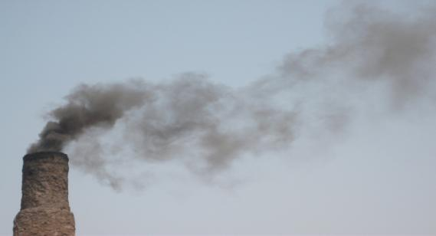

Brick – kiln working in Cha Kasli Wala, dated 15/7/13

In this area many brick - kilns work and contaminated the environment. Dark blackish smoke emitted from the chimneys which was full of dangerous gases such as CO2, methane, CO without any purification. The smoke exhausted from the chimneys in the atmosphere is responsible for the diseases such as Asthma, Skin infections, Lung diseases, as well as the Respiratory diseases in the inhabitants, mostly in female and children.

The length of chimneys of brick - kilns are not enough high to control the pollution. The people that live in this area are in very critical situation due to the smoke. Team observed that the smoke from the factories has prolonged effects on the health of the people. The people of the area were all very upset due to these factories. The people of the area also discussed the different environmental issues they faced. They said that there is no proper sewerage system, solid waste management. There are many places where sewerage water stayed for long.

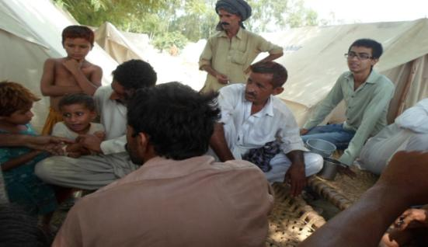

Community discussion at environmental crises in Cha Kasli wala, dated 15/7/13

The people of the area are very much disappointed from the relevant departments such as WASA, Solid Waste Management. Team also observed this problem and visited the places where garbage and house hold waste gathered and get burned.

Team visited Roshni School and met with Miss Qulsoom and discussed environmental issues that are subjected in this area. She told the negligence of WASA and Solid Waste Management. She further discussed an important issue that the female faced severely; she told that excessive spray of different pesticides etc. is a major cause of many diseases in female such as skin cancer, allergic diseases.

In this area different diseases are very common in females such as Allergic diseases, skin infections, asthma. In every home two or three member is affected by the air pollution severely and fetch to poor health.

Team surveyed door to door of the area and discussed environmental issues from the inhabitants. Pathana Mai, Allah Wasai, Hanifan Allah Bakhsh, ZulaikhaYaseen, Ammara, Qulsoom, Razia, Madiha, Aneeqa Afzal, and Esha are very upset due to Air pollution in their area. They requested the government, M N A, M P A, Environment Protection Department, Solid Waste Management, W A S A, for their rehabilitation and do work for managing the problems they faced.

**4.1.8 Community women of Mohallah Raj Ghat UC - 53**

Today we visit Mohallah Raj Ghat for survey. At 09:45 A.M team went to targeted area for survey. During survey of the area it is being noted that the environment of the area was very poor and affected by the pollution.

During survey we observed there is no sewerage system in whole Basti. All the municipal wastes are thrown in crop fields. Many streets were full of sewerage water which is most dangerous for health of the inhabitants.

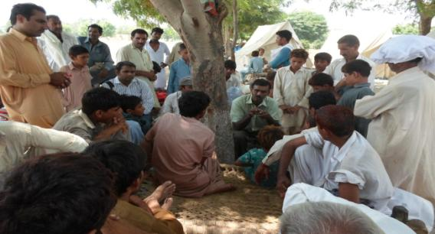

Community discussion at Mohallah Raj Ghat, dated 16/7/13

The people of the area also discussed the different environmental issues they faced. They said that there is no proper sewerage system, solid waste management. There are many places where sewerage water stayed for long. The main problem was the sewerage water which was used in crops fields; due to this activity many diseases are common in this area.

The people of the area are very much disappointed from the relevant departments such as WASA, Solid Waste Management. Team also observed this problem and visited the places where garbage and house hold waste gathered and get burned.

Team visited Roshni School and met with Miss Moazma Ilyas and discussed environmental issues that are subjected in this area. She told the negligence of WASA and Solid Waste Management. She further discussed an important issue that the female faced severely; she told that excessive spray of different pesticides etc. is a major cause of many diseases in female such as skin cancer, allergic diseases. In this area different diseases are very common in females such as Allergic diseases, skin infections, asthma. In every home two or three member is affected by the air pollution severely and fetch to poor health.

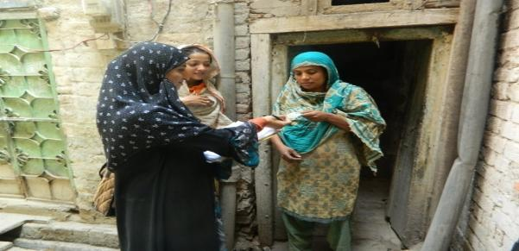

Collection of data by doing door to door survey, dated 21/7/13

Team surveyed door to door of the area and discussed environmental issues from the inhabitants. Ruqia Bano, Haleema Bibi, Shahana, Ayesha, Sonia, Robina, Hina, Tayabba are very upset due to Air pollution in their area.

They requested the government, M N A, M P A, Environment Protection Department, Solid Waste Management, W A S A, for their rehabilitation and do work for managing the problems they faced.

**Chapter 4.2**

**Door to Door Survey**

**Door to Door Survey Data**

**UC - 53**

|  |  |  |  |
| --- | --- | --- | --- |
| Sr # | Name | Occupation | Education |
| 1 | Shumaila | Teacher | Educated |
| 2 | Chanda | Housewife | Non-educated |
| 3 | Shaishta | Housewife | Non-educated |
| 4 | Qurtulain | Student | Educated |
| 5 | Pathana Mai | Housewife | Non-educated |
| 6 | Naheed | Housewife | Non-educated |
| 7 | Fareena Naz | Housewife | Non-educated |
| 8 | Iram | Housewife | Non-educated |
| 9 | Misha | Student | Educated |
| 10 | Asia | Teacher | Educated |
| 11 | Nasir Malik | Clerk | Educated |
| 12 | Sumaira Nousheen | Housewife | Non-educated |
| 13 | Kanwal | Housewife | Non-educated |
| 14 | Azka | Student | Educated |
| 15 | Komal Shehzadi | Housewife | Non-educated |
| 16 | Mumtaz | Housewife | Non-educated |
| 17 | Manzooran bibi | Housewife | Non-educated |
| 18 | Sadia bibi | Housewife | Non-educated |
| 19 | Rehmat bibi | Housewife | Non-educated |
| 20 | Iffat Mai | Housewife | Non-educated |
| 21 | Gurya Bano | Housewife | Non-educated |
| 22 | Faizaa Mai | Housewife | Non-educated |
| 23 | Sakeena Bibi | Housewife | Non-educated |
| 24 | Nasreen bibi | Housewife | Non-educated |
| 25 | Bakho Mai | Housewife | Non-educated |
| 26 | Pathano Bibi | Housewife | Non-educated |
| 27 | Irshad Mai | Housewife | Non-educated |
| 28 | Saeeda Bibi | Housewife | Non-educated |
| 29 | Tehreem Bano | Housewife | Non-educated |
| 30 | Fardous | Student | Educated |

**Door to Door Survey Data**

**UC - 59**

|  |  |  |  |
| --- | --- | --- | --- |
| Sr # | Name | Occupation | Education |
| 1 | Hameeda Mai | Housewife | Non-educated |
| 2 | Haneefa | Housewife | Non-educated |
| 3 | Zulaikha | Housewife | Non-educated |
| 4 | Mukhtaraan Mai | Housewife | Non-educated |
| 5 | Kaneeza Bibi | Housewife | Non-educated |
| 6 | Nageena Bibi | Housewife | Non-educated |
| 7 | Neghat Rasheed | Housewife | Non-educated |
| 8 | Ghulam Fareed | Labor | Non-educated |
| 9 | Waqas | Labor | Non-educated |
| 10 | Shahida | Housewife | Non-educated |
| 11 | Naseem Akhtar | Housewife | Non-educated |
| 12 | Misbah Bano | Housewife | Non-educated |
| 13 | Anum Kabeer | Student | Educated |
| 14 | Asia Komal | Teacher | Educated |
| 15 | Allah Ditta | Labor | Non-educated |
| 16 | Abdullah | Labor | Non-educated |
| 17 | Ishaq Ali | Labor | Educated |
| 18 | Nouman Ali | Labor | Non-educated |
| 19 | Amin Iqbal | Labor | Non-educated |
| 20 | Balqees Iqbal | Housewife | Non-educated |
| 21 | Tehmina Ishfaq | Teacher | Educated |
| 22 | Munawar Bibi | Housewife | Educated |
| 23 | Samreena Naz | Student | Educated |
| 24 | Naghma Bibi | Housewife | Non-educated |
| 25 | Ali Raza | Student | Educated |
| 26 | Qulsoom Bibi | Housewife | Educated |
| 27 | Aziza Mai | Housewife | Non-educated |
| 28 | Sardaran Bibi | Housewife | Non-educated |
| 29 | Razia Bibi | Housewife | Non-educated |
| 30 | Parveen | Housewife | Non-educated |

**Door to Door Survey Album**

|  |  |
| --- | --- |
| G:\Work\d 2 d pics\DSCN0470.JPG | G:\Work\d 2 d pics\DSCN1017.JPG |
| G:\Work\d 2 d pics\DSCN0473.JPG | G:\Work\d 2 d pics\DSCN0476.JPG |
| G:\Work\d 2 d pics\DSCN0479.JPG | G:\Work\d 2 d pics\DSCN0480.JPG |
| G:\Work\d 2 d pics\DSCN0482.JPG | G:\Work\d 2 d pics\DSCN0488.JPG |
| G:\Work\d 2 d pics\DSCN0492.JPG | G:\Work\d 2 d pics\DSCN0778.JPG |
| G:\Work\d 2 d pics\DSCN0783.JPG | G:\Work\d 2 d pics\DSCN0786.JPG |

**Chapter 5**

**Situation Analysis**

**Graphical explanation**

The observed data shows that no one is satisfied of the cleanliness of his area. It shows clearly the main cause of unhealthy environment of UC 53 & 59.

**2**

The observed data shows that there is no proper management of this area. It shows clearly the main cause of unhealthy environment of UC 53 & 59.

**3**

This graph shows the poor management from SWM dept. The basic arrangement for creating a sustainable environment is unavailable in UC 53 & 59.

**4**

Statistical collected data shows an alarming situation of women that are affected by Environmental pollution in UC 53 & 59. Maximum no. of women is affected by the pollutions (smoke, poor quality of drinking water, land pollution).

**5**

The water quality of UC 53 & 59 is very poor, it’s not as good to use for drinking purposes. Health of inhabitants are very much affected by it, food spoiling is most common disease caused by unhealthy water.

**6**

Statistical result shows the unbalance of need and facility. In some areas water filtration plants are working but they did not enough for the inhabitants.

**7**

This graph shows that the there is no awareness among the people, they burn their household garbage and create more poor environment of living.

**8**

Pollution increases at very high level. This is due to lack of proper management of waste, lack of awareness among the people.

**9**

This graph simply shows the efficiency of all relevant departments, work for the betterment of environment.

**10**

There is an alarming situation in UC 53 & 59. The rate of cancer in women gradually increases.

**11**

UC 53 & 59 requires extra work for sustainable environment because the statistical result of the situation of environment is alarming.

**12**

This graph shows that maximum no. of people are uneducated, they didn’t know that their health is at risk due to environmental pollution. 8% people affected now a days and 18% become victims of different skin allergic diseases. Maximum people are affected but they have no idea about the drastic situation of their health.

**13**

Maximum people did not care of their health. They did not consult their doctors for check up. The main reasons are poverty and unawareness.

**Chapter 6**

**In-depth Interviews**

**6.1 Pakistan Girl Guide Association**

We met Girl Guide Director Jabeen Niazi. She told us that this department is established in 1950. She do very hard work even she has a single person in Girl Guide department.

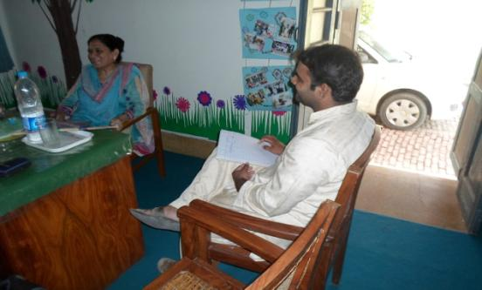

She worked in many projects. She also worked with Rescue 1122. Present days, she work for flood affected people. She conduct a campaign every year in which she grow plant and aware the people how we can clean our environment.

She discussed on environmental issues faced by women. She told us that the environmental changes in Pakistan are at alarming situation because women affect severely and their health is at risk.

In female skin diseases, allergic diseases are common due to environmental hazards. She further told that the excessive use of different types of body spray create a lot of diseases in girls, it also leads to breast cancer.

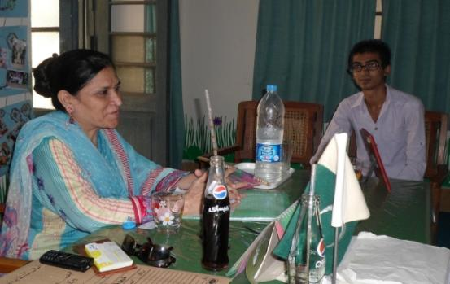

She told us that due to the climate change women did not work properly because they cannot bear the high temperature of Multan.

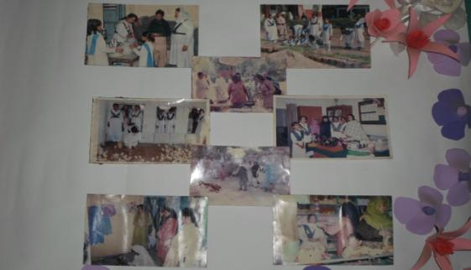

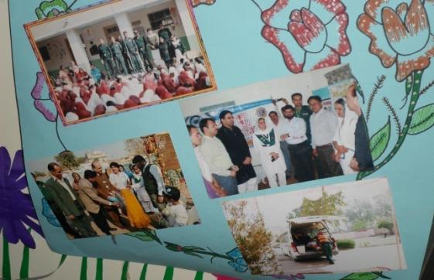

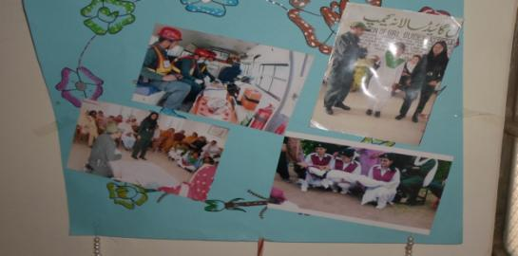

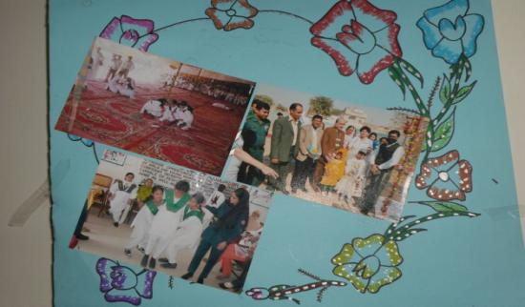

These are the picture presentation of their work.

**6.2 Meeting with Dr. Zahid (senior Dr at Bunyadi Markaz e Sehat) near Sikandri Nala**

Dr. Zahid is working in Bunyadi Markaz e Sehat at UC 59 near sikandri Nala. We went to him to discuss about the problem faced by women due to climate change, and diseases or infections mostly present in the women of that area.

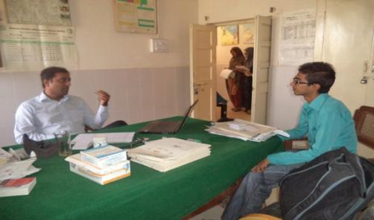

He told us that in this area environment severely affected on females, it disturbs the menstruation cycle and leads to premature birth as well as death of infants.

He also told us that the industrial waste water in which different type of chemicals are present and household waste water is thrown in sikandri Nala without any treatment. This waste water flows along the houses, due to this polluted water human and animal are affected by different diseases.

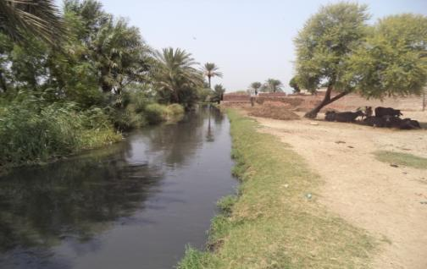

Sewerage water flows near houses and crop fields, dated 10/8/13

People use this sewerage water for irrigation so that crops are also containing contaminated substances in it. These affected crops and vegetables are being used for human.

**6.3 Dr. Muhammad Sibtain Malik**

**(Worked as Naib Nazim of UC-53)**

Dr. Muhammad Sibtain Malik did extra work in UC-53 for rehabilitation of the inhabitants, arranging different awareness campaign on various issues such as Malaria, Diabetes, Asthma, and Anemia and Environmental degradedness.

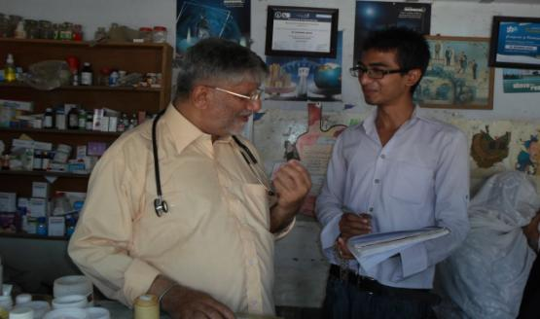

We discussed with him at the diseases that are faced by people of UC 53 mostly common in female. He told us the Environment of this area is affected by water treatment plant severely, lack of sewerage system, unavailability of pure drinking water, lack of awareness of managing solid waste.

He told us the main diseases commonly in women UC 53 are,

1) Anemia

2) Food Poising

3) Asthma

4) Diabetes

5) Malaria

6) Skin allergic diseases

These diseases are spread throughout the community due to Male Nutrition, Blood losses at the time of menstruation, women work in crop fields. He also told that the women of these areas are careless about their health. She did not care disease at early stage, bear pain, took medicine at last stage when disease is acute level.

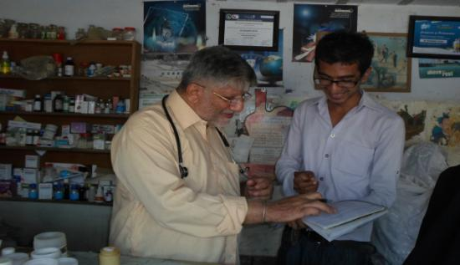

We also discussed Environmental issues such as lack of managing solid waste, Open hole in streets, poor drainage system.

He further told us poverty is the basic reasons of health problems. People are very poor of this area, they did not have the capacity to buy refrigerator, in this situation they have to eat spoil food that is affected by bacteria.

**6.4 Assistant Director Local Government (ADLG)**

We met with Assistant Director Local Government (ADLG). He is the supervisor of all Union Council in Multan region. He is also supervising different projects such as Ramazan package to check the prices.

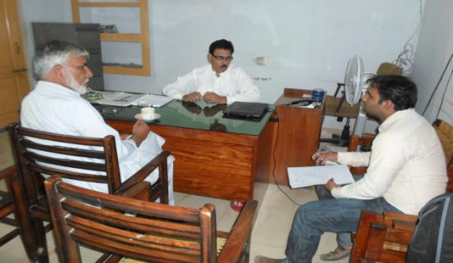

We discussed with him at environmental situation in Multan especially targeted area of our research UC 53 & 59. He told us that he provides funds to Union councils to work for the betterment of environment.

He tell us that Multan has 6 towns and each town has different number of Union Council that are;

Name of Town No. of Union councils

1. Shah Rukn-e-Alam Town 25 Union councils
2. Musa Pak town 19 Union councils
3. Sher Shah town 16 Union councils
4. Shuja Abad town 18 Union councils
5. Bosan Town 24 Union councils
6. 6) Talal pur per wala Town 13 Union councils

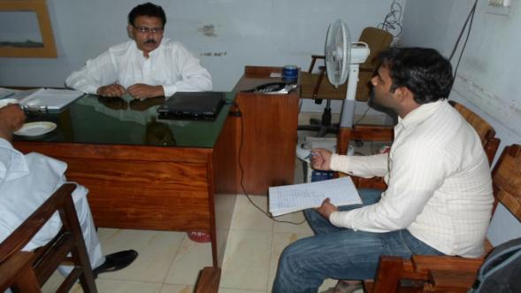

He argued that there is very need to create good environment and started some basic projects about the environment, due to this we provided a safe environment to inhabitants. We should aware people by arranging seminar and starting different projects. Due to these activities people show their interest to keep their environment safe.

He told us that Government provides fund to the Union council officer. He applies those funds that place where fund is needed and he supervised that officers used those funds for the welfare of people or not.

**6.5 Secretary Union Council 53**

We met with the Secretary Union council Muhammad Furqan to discuss the environmental situation of the area. He told us that the UC 53 consists four Mouza named; Mouza Alamdi Soraa, Mouza Tindni, Mouza Raj Ghat and Mouza Ram pur.

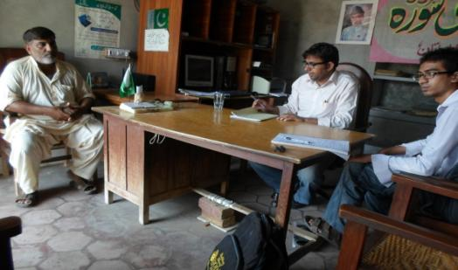

He told that the situation of this area very poor due to Lack of proper management of Solid Waste, poor sewerage system and unavailability of pure drinking water. It leads to major diseases mostly in women such as Male Nutrition, loss of excessive blood in menstruation and food poising.

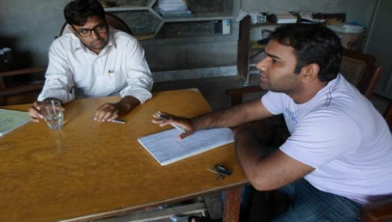

He told us that the drinking water is not good for health. Government started water filtration plant in UC 53, there are 3 filtration plant located at UBL Chok, Darbar Sakhi Sultan and at VIP Colony.

He also discussed that there is no play ground and park for the inhabitants. This UC do not have any hospital or dispensary, due to lack of basic needs of the area the diseases spread fast and people face many health issues.

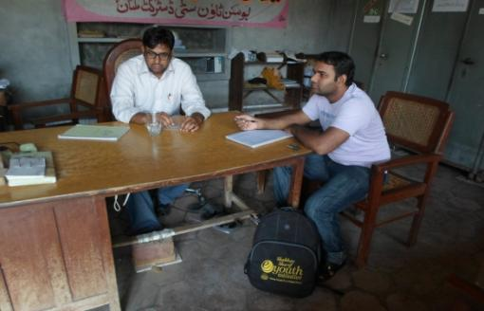

He further discussed that the water purification plant started in this area which creates a lot of problems to the inhabitants. The sewage water is used for plantation and for irrigation crop fields. The uses of sewage water by the plants create many diseases.

**6.6 District Officer Social Welfare**

We met with Madam Nasreen Jaafri (DO social welfare). In meeting we discussed the role of NGO’s on environment. She told us she registered some of NGO’s working for the betterment of Environment. She did also great work for welfare of Multan’s people. In present days she handle the flood affected peoples, the flood destroy mostly that areas which are placed on the bank of the river. She also conducted a campaign to tell the flood affected women about environment of that area which affect women more than men.

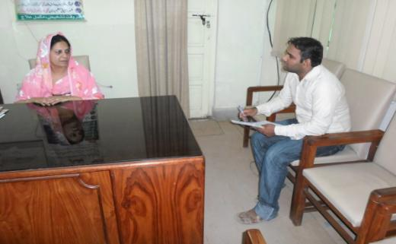

She tells us that she gives the donor to the NGO’s for funding which they use for betterment of people as well as environment. She also facilitates the NGO’s, so that they perform well and do extra ordinary work for the welfare of Multan’s people.

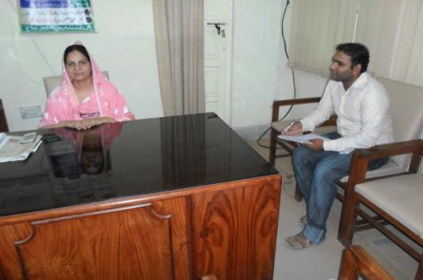

She is also registered the New NGO’s who have strong desire to work for humanity. She told us “Shaoor Tarakki Organization” and “Tarakki Pasand Organization” works with her. She appreciated MEN (Multan Environment Network) and has desire the NGO’s work together and create a better environment for the inhabitants of Multan. She also appreciated our survey on “Impact of Environmental Hazards on Women”. She gave a lot of prayers to us and wished that we complete our research with courage and hardworking

**6.7 District Officer Solid Waste**

We conduct a meeting with District Officer Solid Waste Sir Muhammad Yaar. He told us that the municipal waste is collected at daily bases. There are two landfills, located at Labor Morr and at Habiba Sial. They collect 350 Ton solid waste per day.

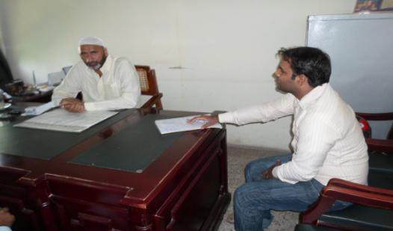

We discussed with him the poor situation of UC 53 and 59. He told us that he is the DO of Multan city. UC 59 is not in city area. In UC 53 there is partially service of management where 10 workers works.

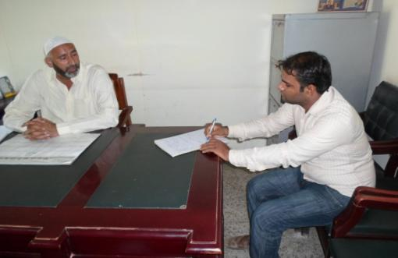

In city areas 35 to 40 workers appointed in every city to collect waste from their area. He also told that the people did not have awareness about management. They throw waste on sewerage line due to this Sewerage system get trouble.

He started a campaign about awareness among the people by wall chalking. He said that we wrote workers name and their contact number, if people face any difficulty they should call them. If the worker did not work properly he can also call me, my contact number also wrote on that wall.

He told us the major problem is the building material, in Multan, many building project work but they did not manage building waste material.

**6.8 District Forest Officer**

We met Faisal Haroon Qurashi. He is the DFO of forest department Multan.

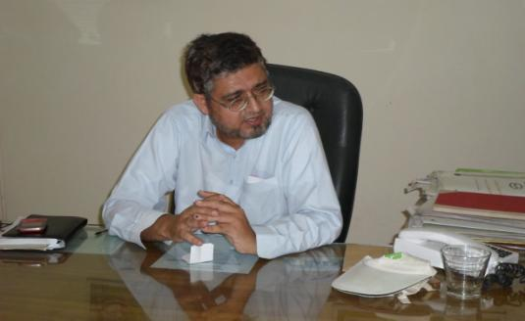

He told us that the plantation was done about 200 Acor in Perowal and 150 Acor in Mirpur. This is an important achievement of DFO because in Pakistan the forest department is completely ignored by the Government. Government did not provide sufficient facilities so the Forest department cannot save forest and trees, which are the best air cleaner and protect us from Storms tornados etc, that’s why the Environment of Pakistan change fast. This change affects women more than men.

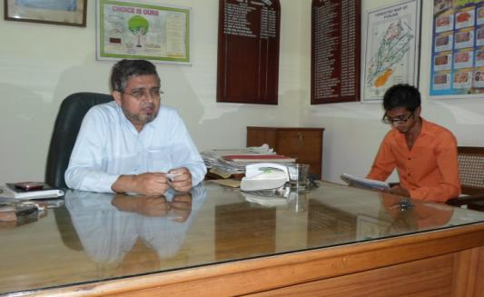

He told that plants and trees are also renewable resources. We should use those resources in the time of energy crisis. He also told that the biodiversity did not present in agricultural land but in forest land because it provides better habitat to wild life.

Now a day, the climate of Pakistan is changing severely than other country. Summer season of Pakistan vast and contain 8 month. This climate change affects women more than man in many ways.

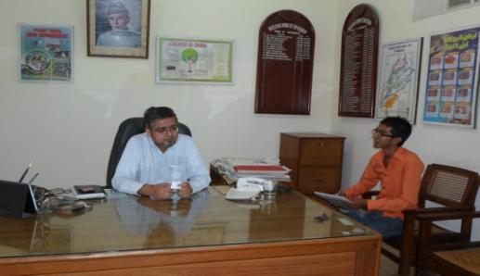

He also discussed the problems that they faced. He told us that the forest guard did not have the facility of motor bike; he visited 30 mail distances on Bicycle. This is a drastic situation and due to this the protection of trees very difficult.

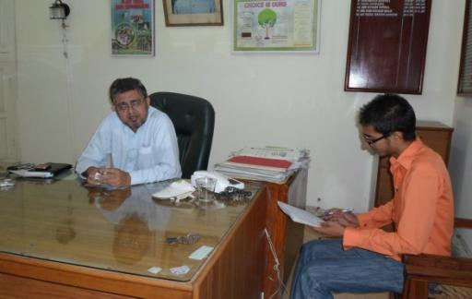

Maximum plant diversity was affected recently when insufficient irrigation water provides to forest. He sent a letter to honorable Chief Minister Shahbaz Sharif so that the supply of needed water provides.

**6.9 Inspector of Environment Protection Department (EPD)**

We had an interview with an Inspector of EPD sir Zaffar Rehman. We discussed with him the projects conducted by the EPD in Multan.

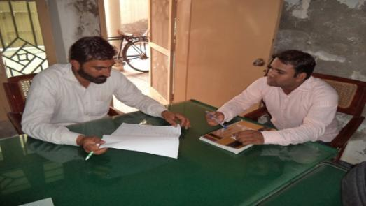

He told us that they conduct self survey, collect data and try to maintain sustainable environment. He told us that laboratory of EPD located at T Chok near Shah Rukn e Alam Colony Multan.

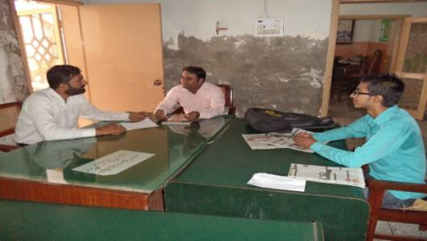

EPD conducted awareness by seminars in different schools and colleges. Due to awareness seminars, students aware and knows about the recent situation of climate and environmental crises in Multan as well as in Pakistan.

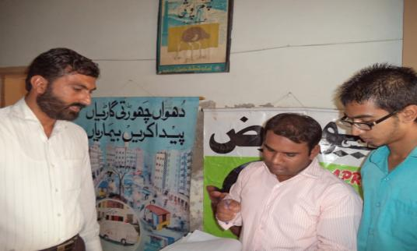

Inspector Zaffar Rehman also told us that they give projects to different NGO’s working for the betterment of Environment. The main difficulty in conducting projects is that the government did not provide sufficient funds.

**6.10 Express News Reporter**

We conduct meeting with Senior News Report Madam Imrana Komal Work with Express News, also she is advocate Multan Bar at Law. She appreciated the research report conduct to highlight the problems of women due to climate change.

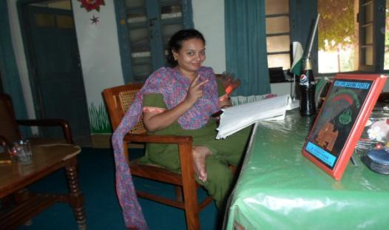

She further discussed that there is drastic situation of women that they severe most as compared to men. Pakistan is at 1st where climate change occurs and create very poor situation of Environment.

She also discussed the Media work about the climate change. She told people aware most due to the media.

**Discussion & Conclusion**

The debate on global warming is at an inﬂection point. Pakistan now is at 1st on Climate change. The summer extends to 8 month of the year. Carbon emission increases gradually as compared to trees that absorb carbon.

We made survey about the hazardous impacts on women in the areas that contain rural, urban and semi urban areas. We conclude that the Environmental Crises are very much in targeted areas Union Council 53 and 59. There is an alarming situation of women that affect by the Environmental pollution.

We conclude that environmental crises in targeted areas lead to cancer, allergic diseases, Asthma and food poising common in women.

There is need to proper management of solid waste, sewerage system and pure supply of drinking water as these are the basic need of inhabitants.

There is need of awareness among the people of targeted areas about environmental degradation.

The Pakistani Environmental Values Survey provides some insights into how to use values as tools to increase awareness and change the attitudes and behaviors of the Pakistani public. We are a collection of divergent, sometimes polarized groups, each with different perspectives and priorities. We don’t all belong to the same religion, live in the same small town, watch the same television programs, or worry about the environment.

Environmentalists could be much more effective by tailoring messages to specific groups of Pakistanis in the same that any for-profit company targets products and advertising to different audiences. One universal message to all of these groups will not only be less effective than tailored marketing based on their concerns, it may well turn off as many people as it motivates.

This is progress but not victory. No longer able cast doubt about the environment, the forces that have impeded progress on global warming will try to shift the arguments to taxes, economic and business costs, mitigation of impacts, and the hopelessness of the situation. They will continue to delay and dilute meaningful action.